PROOF OF CONCEPT · TECHNICAL BLUEPRINT
Infor Support Assistant
A retrieval-augmented support assistant for Infor WMS that runs entirely on one machine. Operators ask questions in plain language; the assistant answers from uploaded manuals, incident and defect exports, and recorded walkthroughs — grounded, source-cited, and confidence-gated, with no data leaving the host.
Project | Classification | Revision | Date | Runtime
Infor Support Assistant | Proof of Concept | 0.1 — draft | 2026-09-04 | Single host / offline / CPU

§1 What this is
The assistant is a local RAG (retrieval-augmented generation) pipeline. Documents are ingested once into a vector store; at question time the system retrieves the passages most likely to answer the query, hands them to a local language model as context, and returns the model's answer alongside the exact sources it drew from.
Every moving part — the language model, the embedding model, the vector store, the reranker, the PII scrubber — runs on the same host as the API. There is no external API key, no cloud inference, and no outbound request in the answer path. That constraint shapes every decision below.

Design principles
- Offline by construction. Ollama serves generation and embeddings from localhost:11434; ChromaDB, BM25, the cross-encoder and spaCy all run in-process. The only network dependency is a one-time model download.
- Answer only from what was uploaded. The model is instructed to use retrieved context exclusively and to name sources by their real file names. A low-confidence retrieval routes to escalation rather than a guess.
- Guarded on both sides. Input is checked for injection and abuse; output is scanned for leaked PII, internal identifiers, and fabricated error numbers before it reaches the user.
- Confidence is explicit. Each answer carries a band — high, medium, or low — derived from the reranker score of the top passage.
- Ingestion is hands-off. A file dropped into data/uploads/ is picked up, routed by type, cleaned, scrubbed, embedded and indexed without operator action.

§2 System architecture
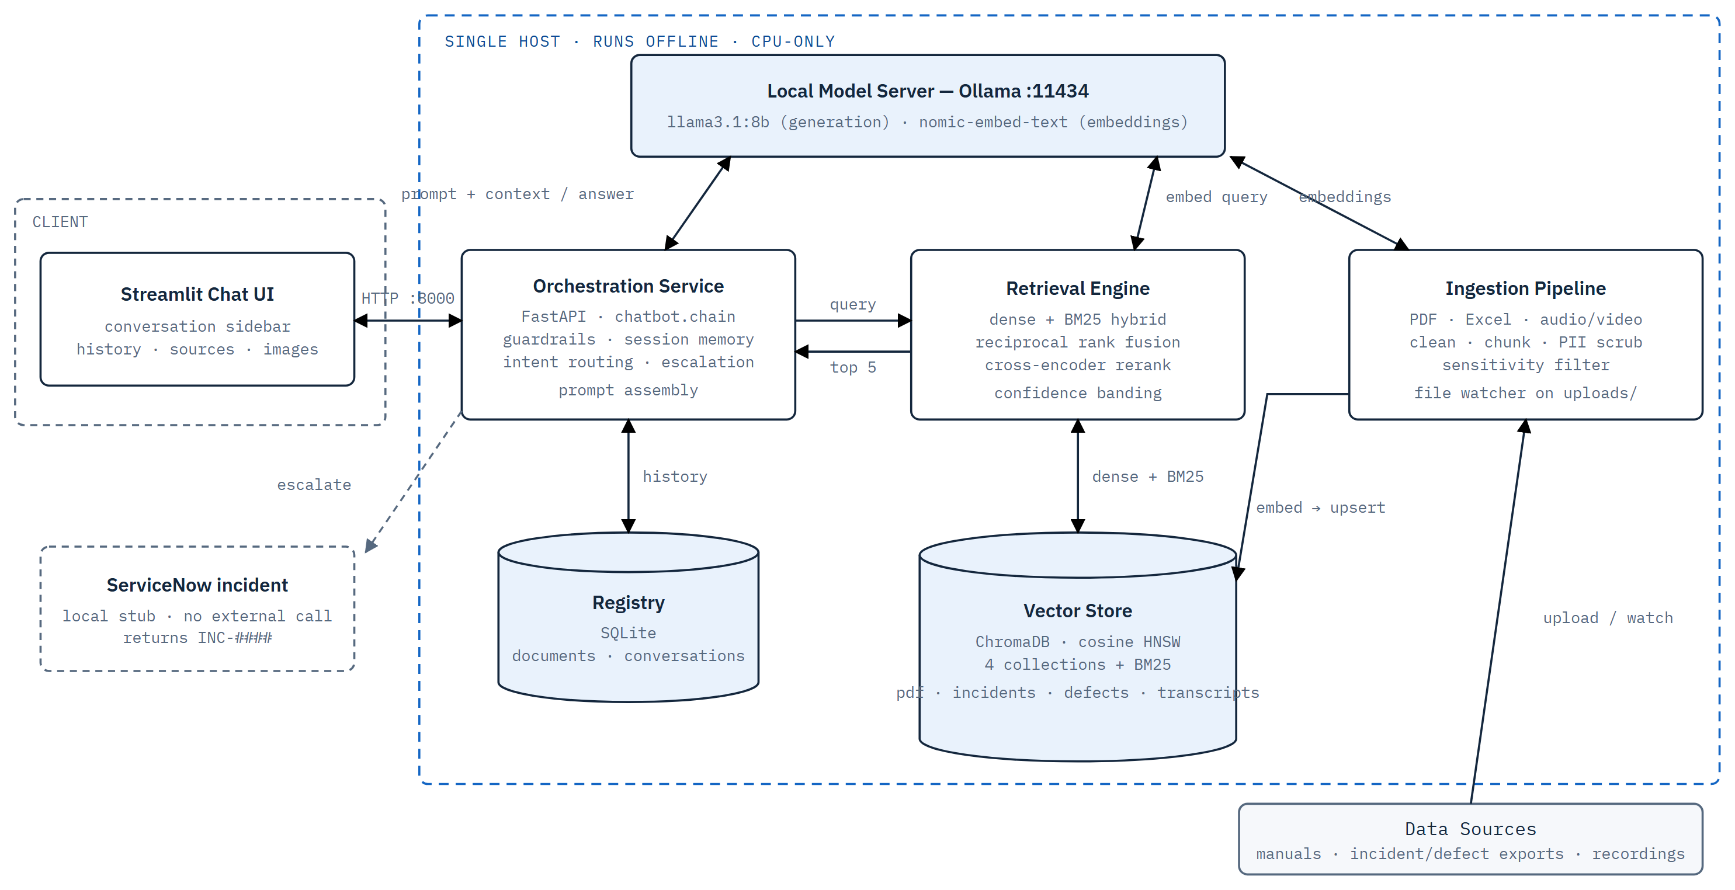
The answer path never leaves the host. The blue dashed boundary is one machine: browser → FastAPI, then the orchestrator fans out to the retrieval engine, the Ollama model server, and the SQLite registry. The ingestion pipeline (right) is the only component that reads external files, and it writes only to the vector store and registry. The ServiceNow box is a stub — it mints a fake INC-#### id and makes no outbound call.
Component | Module | Responsibility
Chat UI | streamlit_app.py | ChatGPT-style front end: conversation sidebar, message history, rendered source citations and figure images. Talks to the API over HTTP only.
API & lifespan | api/main.py | /chat, /upload, /escalate, /conversations*, /documents, /stats, /health. Starts the file watcher and builds BM25 indexes on boot.
Orchestrator | chatbot/chain.py | The RAG chain: guardrail checks, intent detection, follow-up query rewriting, hybrid search, confidence scoring, prompt assembly, LLM call, output validation.
Retrieval | retrieval/hybrid_search.py  retrieval/bm25_index.py  retrieval/confidence_scorer.py | Per-collection dense + keyword search, reciprocal rank fusion, cross-encoder rerank, exact record-id pinning, intent-driven promotion of figures / summaries / transcripts, confidence banding.
Vector store | vectorstore/chroma_store.py | ChromaDB PersistentClient, cosine HNSW, four collections. Upsert, filtered query, delete-by-source helpers.
Ingestion | ingestion/pdf_ingester.py  ingestion/excel_ingester.py  ingestion/video_ingester.py  ingestion/file_watcher.py | Type-specific extraction and chunking, shared PII scrub + sensitivity filter, batched embedding, upsert, BM25 rebuild, registry updates. Auto-triggered by the watcher.
Security | security/pii_scrubber.py  security/sensitivity_tagger.py  guardrails/*.py | Presidio + spaCy PII redaction, keyword sensitivity tagging, and the input / output guardrails.
Registry | registry/document_registry.py  chatbot/conversation_store.py | SQLite: document lifecycle (doc_id, filename, type, version, status, chunk count) and durable chat history that survives restarts.
Escalation | chatbot/servicenow_handler.py | Builds an incident payload from the conversation and returns a dummy INC<timestamp>. No integration — a placeholder for a real connector.
Desktop shell | desktop_app.py | Optional pywebview wrapper that packages the Streamlit UI as a native window.

§3 Request lifecycle
A question passes through a fixed sequence of gates. Two of them — an explicit escalation request and a low-confidence retrieval — can divert the request away from the language model entirely.
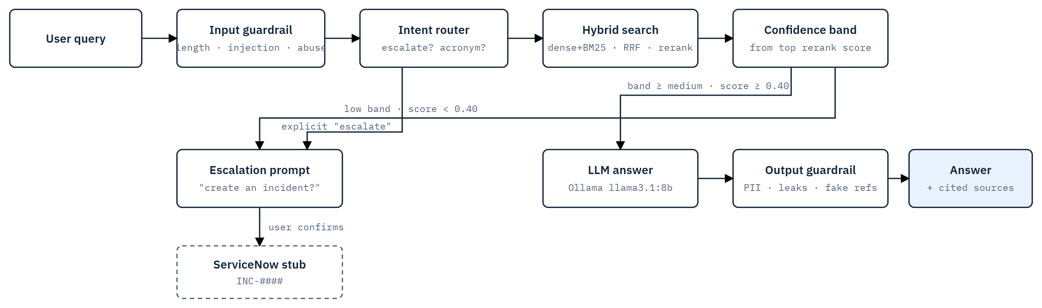
Two exits skip the model. The intent router catches an explicit "escalate / raise an incident" before any retrieval runs. Otherwise the confidence band on the top reranked passage decides: ≥ 0.40 goes to the LLM; < 0.40 offers escalation instead of guessing. A short factual query is nudged up one band so a one-line lookup is not forced to escalate.
0 · pending check — If the previous turn offered escalation, a yes / no here is handled before anything else.
1 · input guardrail — Empty, over-length (> 500 chars), prompt-injection patterns, or abuse → rejected with a plain message.
2 · intent router — Escalation phrasing → confirmation prompt. Acronym / "what does X stand for" → BM25 definition lookup, no LLM.
3 · query rewrite — Short follow-ups are enriched with the entity or topic from the previous turn (heuristic, no model call).
4 · hybrid search — Dense + BM25 per collection → RRF → cross-encoder rerank → top 5. Confidence = normalized score of rank 1.
5 · escalation gate — Low band → offer to raise an incident. The original query is held for the payload.
6 · generation — Context block + conversation history + banded instructions → llama3.1:8b at temperature 0.1.
7 · output guardrail — Redact PII, strip internal identifiers, flag error numbers absent from the context, truncate to the token cap.

§4 Ingestion pipelines
Three source types share one back half. Each has its own extractor; from the chunking step onward the path is identical — scrub, filter, embed, index. The target collection is chosen by file type, and for spreadsheets by file name.
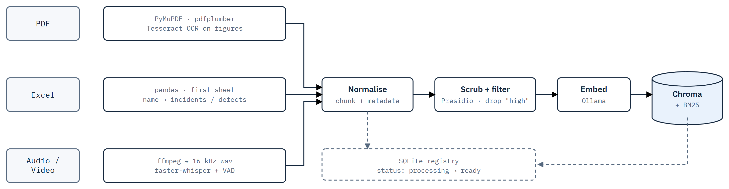
One shared back half. Extraction differs per type; everything after Normalise is common code. A spreadsheet whose name contains neither "incident" nor "defect" is rejected at upload, as is any file whose name was ingested before. The embed step batches 128 chunks per Ollama call.
PDF — Text blocks, tables (pdfplumber), and embedded raster figures. Figures are detected by image size and page position — not by caption — then run through Tesseract so diagram labels become searchable text. Figure images are saved and served back with the answer.
Excel — Generic single-sheet reader: first row is the header, columns are arbitrary. One chunk per row plus a sheet-overview chunk for "how many" questions. Every column is kept as col_* metadata. Routed to incident_tickets or defect_records by file name.
Audio / video — ffmpeg extracts a 16 kHz mono track; faster-whisper ("medium" + voice activity detection) transcribes it. Segments are merged into ~60-second / 700-character windows, each carrying its timestamp, plus one full-transcript overview chunk. Sidecar .srt / .json are written too.

§5 Retrieval & confidence
Retrieval runs every collection in parallel as independent ranked lists, then fuses them so a large collection cannot outweigh a small one by sheer volume. Fusion feeds a cross-encoder, which is the score that actually decides the answer.
dense — Top 20 per collection from ChromaDB, cosine similarity on nomic-embed-text vectors.
sparse — Top 20 per collection from a per-collection BM25 Okapi index, rebuilt after every ingest.
fusion — Reciprocal rank fusion, k = 60, ranked within each list — every list's rank 1 contributes 1/(k+1). Fused to 10, plus each collection's own best candidate.
rerank — cross-encoder/ms-marco-MiniLM-L-6-v2 scores every query–passage pair; top 5 survive.
exact id — A bare record token in the query (e.g. SNOW8729267) is looked up by row_key and pinned to rank 0.
promotions — Figure-intent, aggregate-intent ("how many"), and transcript-intent queries each force their matching chunk type into the result set if absent.

Band | Score | Behaviour
high | ≥ 0.75 | Answer directly and completely from context.
medium | 0.40 – 0.75 | Answer, but instructed to extract inline detail and note gaps.
low | < 0.40 | No LLM call — offer to raise an incident instead.

§6 Security & guardrails
Input guardrail — Rejects empty input, queries over 500 characters, prompt-injection patterns ("ignore previous instructions", "you are now…", [system]), and abusive language — each with a specific message.
Output guardrail — Regex-redacts email / phone / IP / SSN from the model's reply, replaces leaked internal terms (chromadb, doc_id, file paths) with [internal], flags error numbers not present in the retrieved context, and truncates to the response token cap.
PII scrub (ingest) — Presidio + spaCy (en_core_web_sm, trimmed pipeline) redact PERSON, EMAIL_ADDRESS, PHONE_NUMBER, IP_ADDRESS, US_SSN, CREDIT_CARD, IBAN_CODE before anything is embedded. Runs as one batched NLP pass over all chunks.
Sensitivity filter — Keyword tagging (salary, payroll, confidential, password, credential…). A chunk tagged "high" is dropped — never embedded, never retrievable. Figure chunks are flagged as possibly containing PII in the image itself.
URL and LOCATION are deliberately not redacted: URL redaction removes document links and hurts retrieval; LOCATION rarely carries real PII in ERP material and is costly to detect.

§7 Data stores
Collection | Fed by | Chunk types | Key metadata
pdf_chunks | PDF ingester | text, table, figure | page, section, chunk_type, image_path
incident_tickets | Excel, name contains "incident" | excel_row, sheet_summary | row_number, row_key, col_*
defect_records | Excel, name contains "defect" / "bug" | excel_row, sheet_summary | row_number, row_key, col_*
video_transcripts | Audio / video ingester | transcript_segment, transcript_summary | start_sec, end_sec, start_time, segment_index

Vector index — ChromaDB PersistentClient at vectorstore/chroma_db/, cosine HNSW. Every collection also has a pickled BM25 index under vectorstore/bm25_indexes/.
document_registry.db — One row per ingested file: doc_id, filename, source type, version, status, chunk count, timestamp. Drives duplicate-name rejection.
conversations.db — Conversations and messages with confidence, sources and images. The chat window is rehydrated from here after a restart.
data/ layout — uploads/ (watched), figures/ (served), transcripts/ (sidecars). Nothing here is authoritative — the vector store and registry are.

§8 Technology stack
Models (local) — Ollama — llama3.1:8b, nomic-embed-text (768-dim). sentence-transformers 4.1 cross-encoder. spaCy en_core_web_sm 3.8. faster-whisper 1.1.
Retrieval & store — chromadb, rank-bm25 0.2.2. Orchestration glue from langchain 0.3.25 / langchain-community / langchain-ollama.
Ingestion — pymupdf 1.25.5, pdfplumber 0.11.6, pytesseract 0.3.13 + Tesseract binary, pandas 2.3.3 / openpyxl 3.1.5, ffmpeg binary, watchdog 6.0.
Service & UI — fastapi 0.115 / uvicorn 0.34, streamlit 1.45, pywebview 6.2, SQLAlchemy 2.0, presidio-analyzer / anonymizer 2.2.356.
External binaries required on the host: Ollama, Tesseract OCR, ffmpeg. Everything else installs from requirements.txt.

§9 Known limits & next steps
Limit | Detail | Direction
CPU-only inference | Embedding is ~83% of ingestion wall-clock; generation is the slowest step at query time. Concurrency gave no gain on shared cores. | A GPU for Ollama is the single biggest speedup. Batch size and concurrency are already env-configurable for that day.
Vector-drawn diagrams | Only embedded raster images are extracted from PDFs. Diagrams drawn as vector paths are not captured as figures. | Cluster drawing-operation bounding boxes and render those regions to raster before OCR.
Table-of-contents noise | Dotted TOC lines can rank as high-confidence sources. | Filter leader-dot / page-number-only chunks at clean time.
Escalation is a stub | No real ticketing integration; the incident id is synthetic. | Replace servicenow_handler with a real connector behind the same interface.
Single tenant | No authentication on the API; one shared conversation store; assumes a trusted local network. | Add auth and per-user scoping before any multi-user deployment.
Transcription quality | Accuracy tracks source audio; quiet or noisy recordings degrade badly even at the "medium" model. | Surface a confidence signal per transcript; allow a larger model where the host can afford it.

Infor Support Assistant · Blueprint rev 0.1 · Proof of concept — not a production system · 2026-09-04

